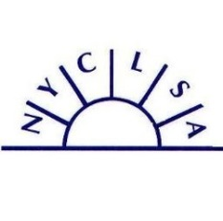
NYCLSA Virtual Event
April 16, 2021

Registration

Member registration $10. Non-members, $40; includes a one-year NYCLSA membership.
Please send a check made out to NYCLSA. Mail to J. Neuburger, NYCLSA Spring 2021 Event, 128 Brookside Lane, Fayetteville NY 13066
Name
Title
Department
Institution and Address

Email
Phone (Work and home/cell)
Home Address
PLEASE GO TO PAGE TWO

We will have break-out sessions for this webinar on
Learning Centers: Moving Forward by Looking Back: Identifying Useful Lessons for the Future from the Pandemic Era.
Please answer the following questions so we can group you with others. Please send this file electronically to janeneuburger@outlook.com and to michele.doney@baruch.cuny.edu. NYCLSA is working to get a Paypal account and that should be ready before our fall one day F2F conference at the Radisson in Corning NY. Please watch for alerts for our first “after-the-pandemic” live conference!

Your name

- Is your institution largely commuter or residential?

- Is your institution public or private?

- Is your institution largely a community/technical, two-year, or a four-year college?

- Are you willing to have your name and email address included on a list of participants to be shared after the webinar ends to make it easier for participants to connect?

- What types of learning assistance programs do you offer?

- What percent (approximately) of your learning assistance programs are taking place in person this spring?
- What percent (approximately) of your learning assistance programs will take place in person in the fall?

